### UE20CS301

## Database Management System

## Lab 6 – Aggregate Functions

Name : Renita Kurian

SRN : PES1UG20CS331

Roll No. : 13

1. Find the average distance between subsequent stations for every train

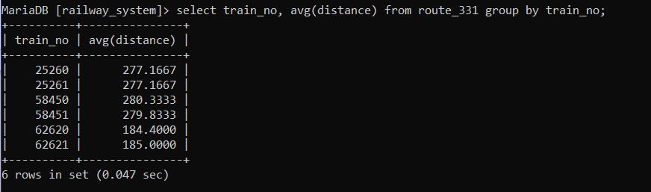

2. Find the average distance between subsequent stations for every train and display them in descending order of distance

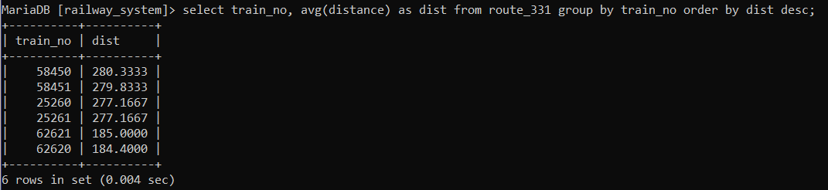

3. Display the list of train numbers and the total distance travelled by each in descending order of the distance travelled

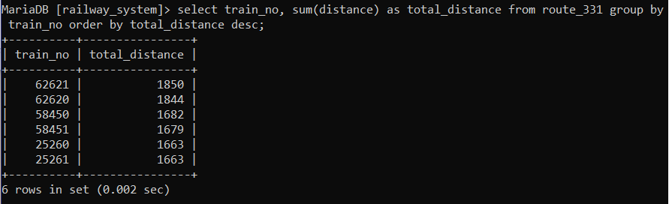

4. List those trains that have maximum and minimum number compartments and also display number of compartments they have. (2 queries one to find max and other to find min)

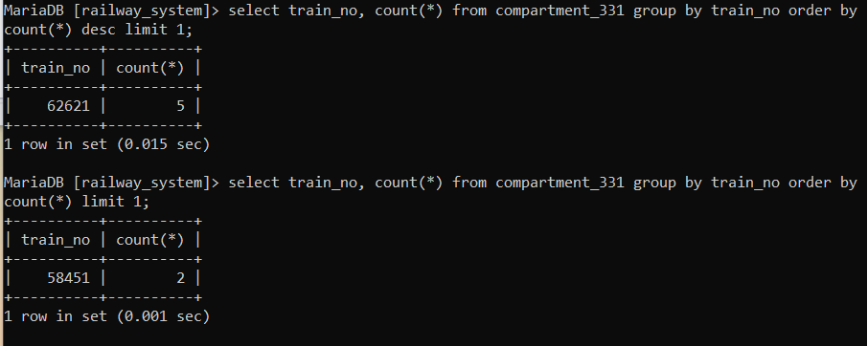

5. Display the number of phone numbers corresponding to the user_id(s) ADM_001, USR_006, USR_10

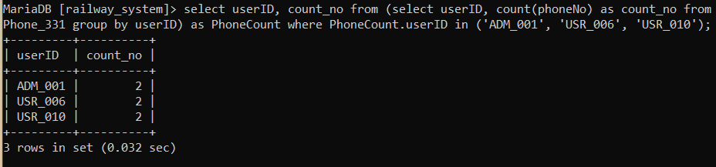

6. Find the average fare per km for each train type specified and display the train type and corresponding average fare per km as ‘Avg_Fare’ in decreasing order of Avg_Fare

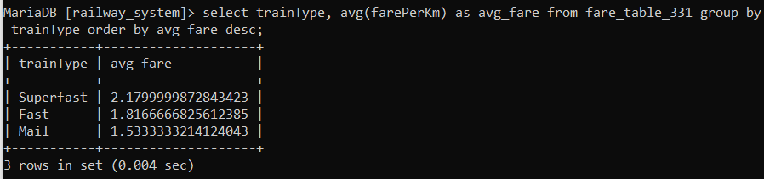

7. Retrieve all details of the oldest passenger.

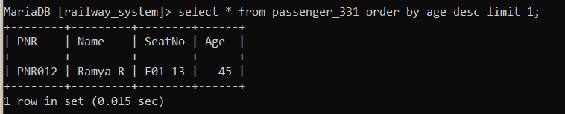

8. Count the number of passengers whose name consists of ‘Ullal’. (Hint: Use the LIKE operator)

